Memorial Service for Retired Fire Captain Gordon Wallace
December 1, 1924 to August 2, 2015
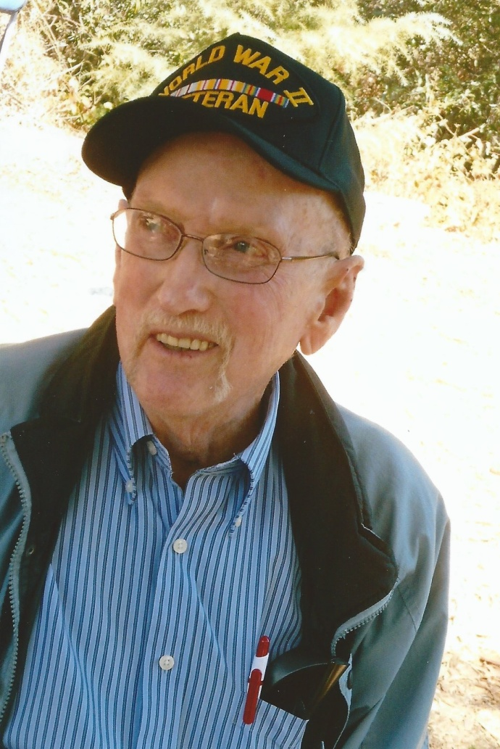
Please join the Wallace Family and the San Jose Fire Museum as we celebrate Gordon's life and his 25 year career as a San Jose Firefighter.
Date is September 26th, 2015.
Location is San Jose Fire Museum, 1661 Senter Road, Building #D1, San Jose, CA 95112
Time is 10am to 12:30pm.
10 to 10:30am - Guest arrive and mingle.
10:30 to 11:30am - Memorial Service
11:30am to 12:30PM - Reception & light refreshments will be provided.

Parking will be on the site around the Fire Museum Warehouse.
Dress is casual, except for any on shift SJFD Firefighters who will be in station uniform.
RSVP is not required.

