Memorial Service for Retired SJFD Fire Engineer Mike Rosingana
July 17, 1944 to July 10, 2015
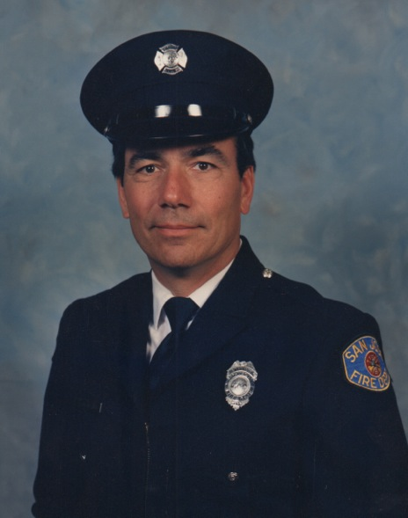

Please join the Rosingana Family and the San Jose Fire Museum as we celebrate Mike's life and his 30 year career as a San Jose Firefighter.
Date is August 29th.
Location is San Jose Fire Museum Warehouse, 1661 Senter Road, Building D1, San Jose, CA, 95112.
Time: 9 am to 12 noon
9am to 10am - guest arrive and mingle
10am to 11am - Memorial Service
11am to 12 noon - reception, light refreshments will be provided.
Parking will be on the site around the Fire Museum Warehouse.
Dress is casual, except for any on shift SJFD Firefighters who will be in station uniform.
RSVP is not required.

